TASK 3: DATA ANALYSIS WITH PANDAS
Name
Gaddala Sathwik
Internship Domain
Python Developer
Objective
The objective of this task is to perform data analysis using the Pandas library by loading a CSV dataset, inspecting data, applying filtering and grouping operations, and generating useful insights.
Tools Used
- Python
- Pandas Library
- Visual Studio Code (VS Code)
Program Description
The program loads a sales dataset from a CSV file and performs data analysis. It checks for missing values, filters data based on categories, groups data to calculate total sales, identifies the highest-selling product, and generates simple business insights.

Source Code
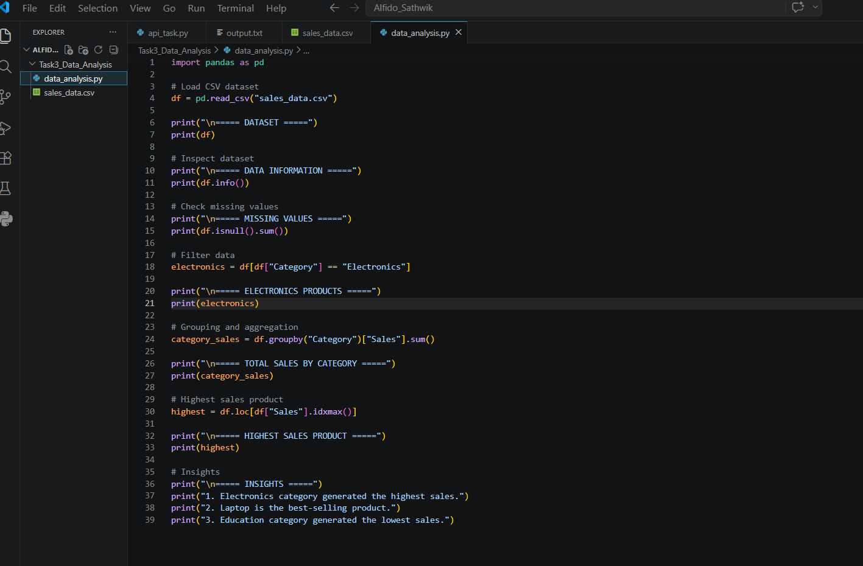

Output Screenshots
Screenshot: CSV Dataset
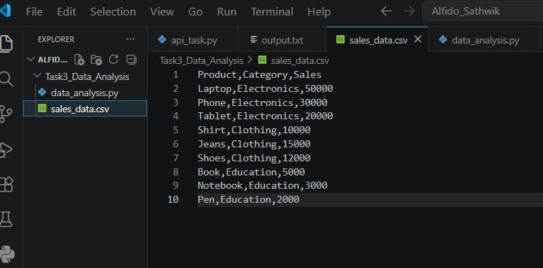

Screenshot: Program Execution
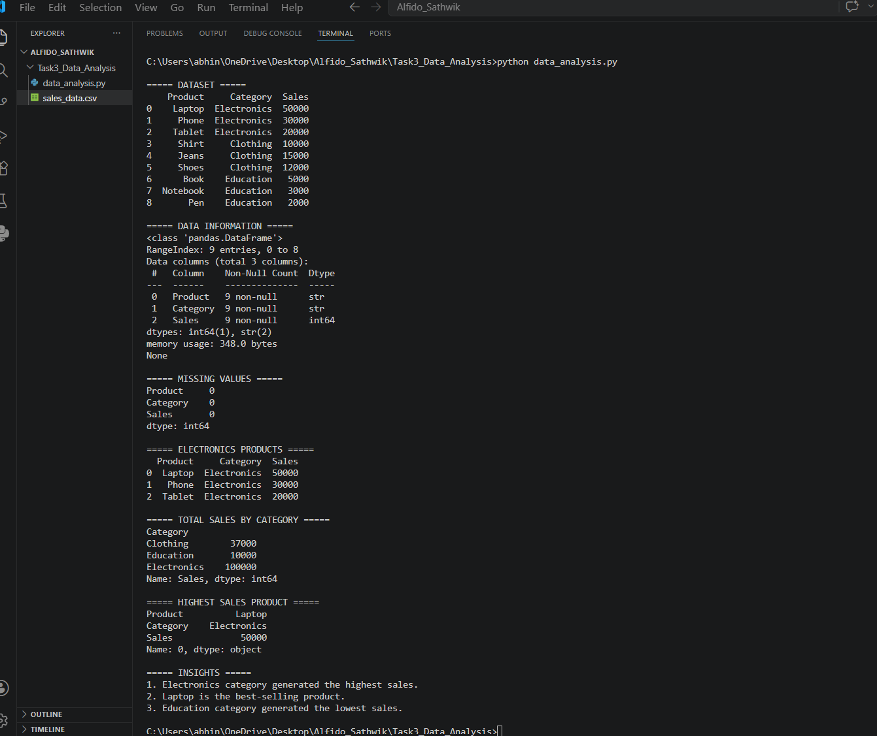

Insights
- Electronics category generated the highest sales.
- Laptop is the highest-selling product.
- Education category generated the lowest sales.
Result
The dataset was successfully analyzed using Pandas. Filtering, grouping, aggregation, and inspection operations were performed successfully.
Conclusion
This task helped in understanding how Pandas can be used to analyze datasets, identify trends, and generate meaningful insights from data.

